## User manual

### Login

When the application is launched, the system will display a login form. The user has to put in its username and password and then to click on “LOGIN” button. If desired, the user can also see its password as plain text by clicking on the “Show/Hide Password” radio button.

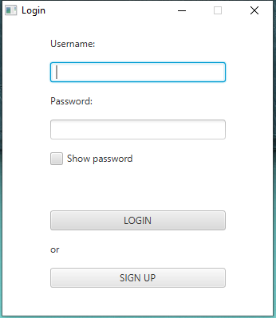

### Sign-up

If the user doesn’t have credentials for the application, he can register himself to the service pressing the button SIGN UP. He has to insert his First Name, Last Name, Date of Birth, email and the desired username and password. After pressing the button REGISTER, the system will show a message which will explain the result of the registration process.

### Working with the application

### Administrator case

If the user is the administrator of the application, the main page showed will be the administrator control panel in which the admin can manage the setting of the application.

Here the admin can see the list of all the users registered and their related information.

The admin can also decide from which newspaper sites the application has to do the scraping of the articles. In particular he has to click on the checkbox of the desired websites and after that he has to click on the “APPLY” button.

The admin can manage also the scraping period of the application. He can specify in the “Scraping period” textfield the desired interval of time ( in minutes ). After the decision of the period, he has to click on the “UPDATE” button.

Instead of specifying a new scraping period, the admin can also force the scraping operation clicking on the “SCRAPE NOW” button. In this way the application receive the scraping command and starts to retrieve the articles from the specified sites.

### User case

Once the application has loaded the main page, the user can visualize two main tables.

The first table contains the trending keywords of the last week. In particular the user can click on one of those keywords. After that, the application will insert the selected word into the “Search Keyword” textfield. The user can start the search of the articles related to the keyword, specifying or not some filters, clicking on the “SEARCH” button.

The second table contains a list of recommended articles for the user. That list is based on the history of the user’s view. The user can scroll that list seeing the information about the articles. Moving the cursor on one of those articles, the user will see in the below table (Single Article overview) the article’s text analysis which contains the list of all the article’s word and their number of occurrence.

If the user clicks on a recommended article in the table, the application will open in the browser the newspaper web page containing the entire article.

The user has also the possibility to create his own search. In particular he can specify the desired keyword in the “Search keyword” field and specifying also some filters if he wants (like authors, City, Newspaper). After clicking the “Search” button the application will show the Result table which will contain the results of the user’s search.

The user can scroll that list seeing the information about the articles. Moving the cursor on one of those articles, the user will see in the below table (Single Article overview) the article’s text analysis which contains the list of all the article’s word and their number of occurrence. If the user clicks on a article in the Result table, the application will open in the browser the newspaper web page containing the entire article.